Yeading Court Surgery

Virtual PPG JOINING FORM

I would like to join my GP practice virtual PPG

Name:

Address:

Phone number:

Email:

Date:

Signature:

1-2 Yeading Court, Masefield Lane,

Hayes,Middlesex, UB4 9AJ

Tel: 0208 845 1515

www.yeadingcourt.nhs.uk

**Virtual Patient Participation Group (PPG)**

The date of the next PPG meeting

We are a group of patients working together with the practice staff to improve our GP practice services for everyone

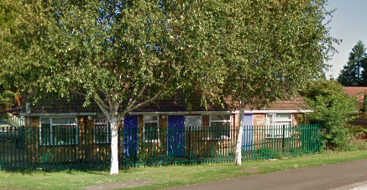

PLACE

TIME DATE

**Join us!**

We welcome all practice patients and carers of registered patients to share their ideas, skills and enthusiasm

Come to the meetings held at our GP practice or get involved by joining our Virtual Patient Participation Group

**Where do we meet?**

For the time being we are trailing our PPG as a virtual group being held over Microsoft Teams.

**Who attends the meeting?**

Our Patient Participation Group meetings are attended by the practice patients, carers of registered patients and a few GP practice staff, usually a GP, the Practice Manager or the Reception Manager

**What happens at the meeting?**

A Patient Chair (usually one of the GP partner) manages the meeting supported by a Secretary (the practice manager) who takes minutes.

We discuss agenda items, agree the action plan for services improvements and monitor the agreed implementations.

A PPG meeting Agenda may look like this:

1. Welcome and introductions
2. Updates from GP Practice staff
3. Patients’ feedback, suggestions and comments
4. Small project ideas and updates
5. Agreed action plan
6. Date of the next meeting

The meeting lasts about 1 hour.

**What do we do?**

* + We gather patients’ feedback
  + We review patients’ surveys
  + We explore ideas and suggestions on how to improve patients’ experiences in our GP practice
  + We discuss with GP Practice staff and agree on an action plan for service improvements
  + We monitor the implementation of the service improvement action pan
  + We run small projects that benefit all practice patients such as health

Promotion, patients’ education, improvement to practice environment

**What we DON’T do?**

* A PPG meeting is not a forum to raise individual complaint
* A PPG meeting is not a forum to seek medical advice

Join us!

**How to join our practice PPG?**

If you are interested in joining our Patient Participation Group meetings or the Virtual Patient Participation Group, please fill in the form overleaf and return to the reception.

Alternatively, go to our GP Practice website to join the Patient Participation Group on line:

www.thestationpractice.co.uk

**Confidentiality**

Your details will not be shared with anyone beyond this GP practice.

We will contact you from time to time to let you know the dates of the PPG meeting